Asia-Pacific Economic Dynamics (2020–2025)

Growth, Stability, and Macroeconomic Trade-offs in APDREO Economies

Author: Kaustubh Sardesai
Date: January 2026
Tools Used: SQL, Excel, Tableau
Context: Self-Initiated Portfolio Project

Executive Summary
This report analyses macroeconomic trends across Asia and the Pacific using APDREO data from 2020 to 2025, with focused deep dives on the region’s five largest economies where appropriate. The analysis examines growth performance, inflation dynamics, labour market stability, and external balances during a period shaped by pandemic recovery and global tightening cycles. Results show meaningful divergence in growth resilience, inflation–growth trade-offs, and current account dependence across economies. These insights are intended to support economic monitoring, investment analysis, and policy evaluation.

Business Task
The objective of this analysis is to assess the performance of Asia-Pacific economies across key macroeconomic indicators between 2020 and 2025, and to identify which economies demonstrate resilience, volatility, or structural dependence. The analysis focuses on understanding growth sustainability, price stability, labour market outcomes, and external balance risks within the APDREO framework.

Key Stakeholders
- Economic and policy analysts
- Investment and risk assessment teams
- Business strategy and market entry teams
- Data and economic research recruiters

Data Sources
The analysis uses APDREO macroeconomic indicators covering Asia-Pacific economies from 2020 to 2025. Key indicators include GDP growth (constant prices), inflation (CPI, period average), unemployment rates, and current account balances as a percentage of GDP. The dataset is subject to standard macroeconomic revision cycles and cross-country methodological differences.

Tools and Methodology
SQL was used for data cleaning, transformation, aggregation, and analytical querying. Excel supported validation and sense checks, while Tableau was used to create comparative time-series and cross-sectional visualisations. Analytical techniques included multi-year averaging, volatility range analysis, and cross-indicator comparisons to surface structural patterns rather than single-year effects.

Data Preparation and Cleaning
Data preparation steps included duplicate validation, removal of non-relevant indicators, filtering to the 2020–2025 period, and standardisation of numeric precision. Indicators outside the analytical scope were excluded to improve clarity. For visualisation clarity, selected analyses focus on the five largest Asia-Pacific economies (China, Japan, India, Australia, and South Korea), while broader regional coverage is retained where comparative context adds value.

Analysis and Key Insights

Divergent GDP Growth Trajectories Among Asia-Pacific Economies
Across the 2020–2025 period, GDP growth trajectories diverged significantly among major Asia-Pacific economies. High-growth economies such as India maintained consistently positive average growth across the period, while others experienced sharper contractions followed by recoveries. The spread between maximum and minimum annual growth rates highlights materially different recovery paths and sensitivity to external shocks.

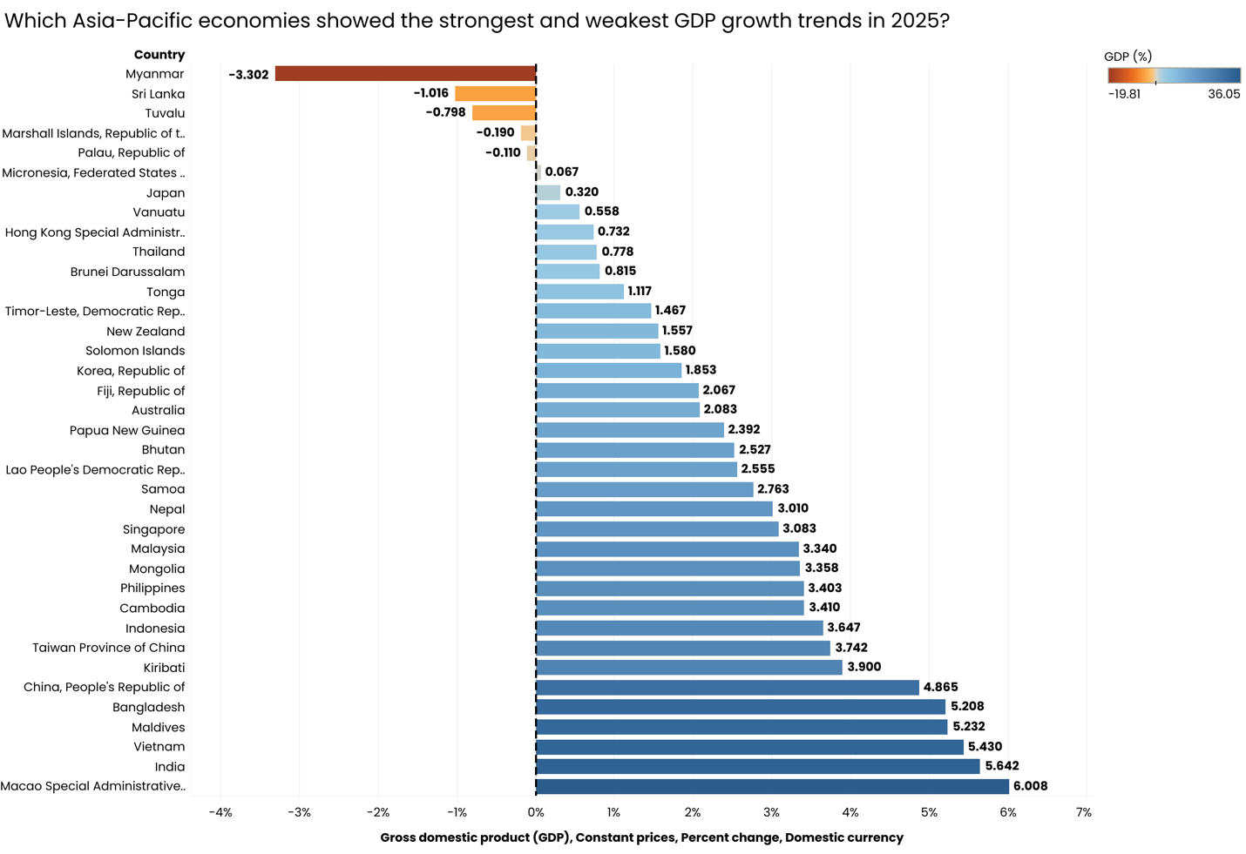

Inflation Pressures Do Not Scale Linearly With Growth
Comparison of average GDP growth and average inflation shows that higher growth does not necessarily coincide with proportionally higher inflation. Some economies sustained moderate growth with relatively contained inflation, while others experienced elevated price pressures despite weaker growth performance. This suggests differing monetary transmission mechanisms and supply-side constraints across the region.

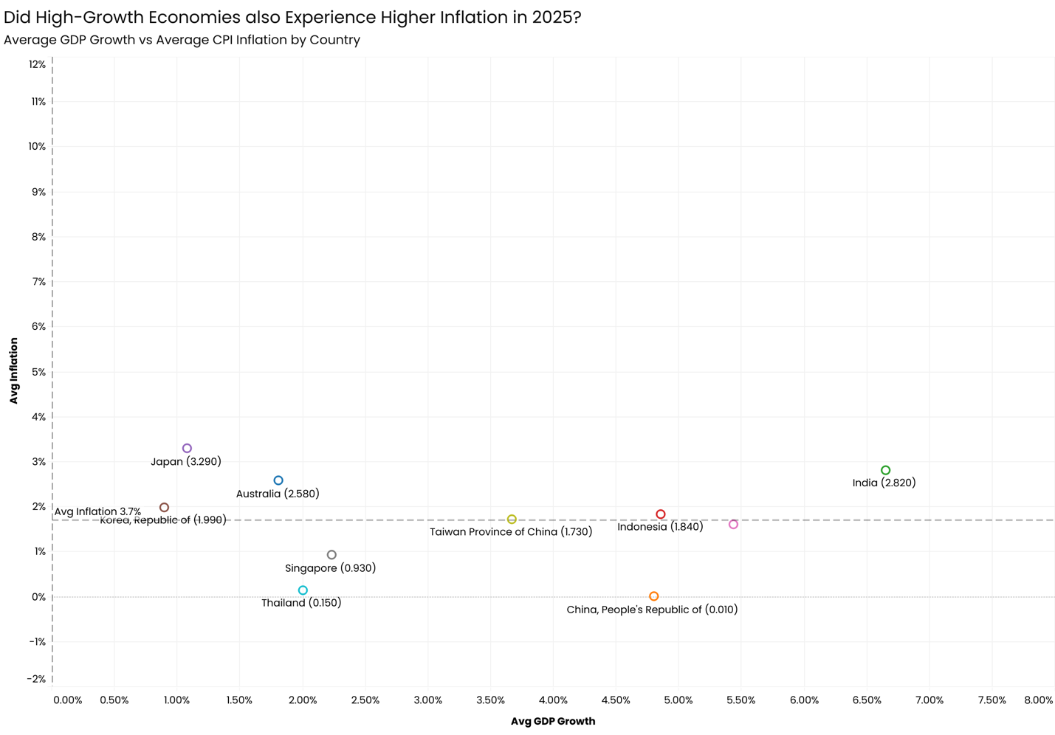
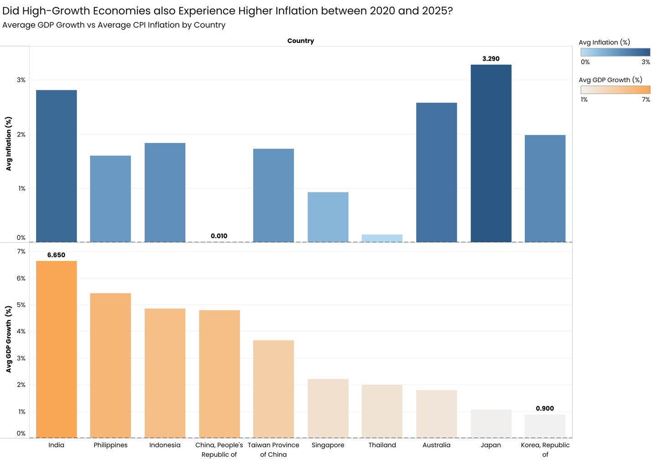

Labour Market Stability Varies Sharply Across Economies
Unemployment trends reveal varying degrees of labour market resilience. Economies with more flexible labour structures exhibited lower volatility in unemployment rates, while others showed pronounced fluctuations during the recovery phase. When combined with inflation and growth metrics, these differences help distinguish structurally stable economies from those experiencing cyclical stress.

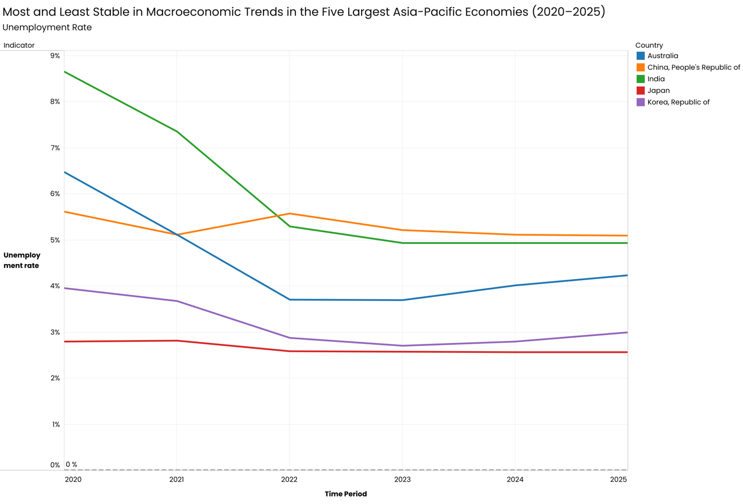
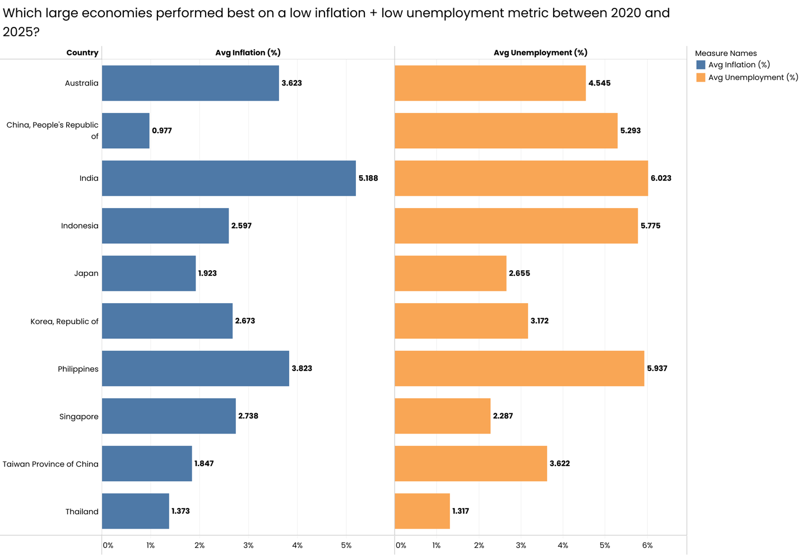

Current Account Positions Indicate Structural External Dependence
Current account balances as a percentage of GDP highlight which economies rely more heavily on external financing. Persistent deficits suggest structural dependence on foreign capital, increasing exposure to global financial tightening. Conversely, economies with sustained surpluses exhibit greater external buffers during periods of volatility.

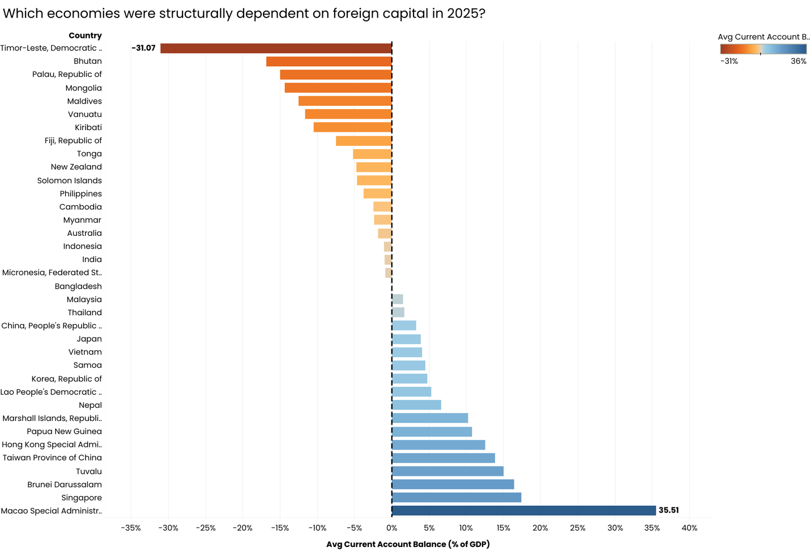

Consistency Matters More Than Peak Performance
An assessment of average GDP growth against growth volatility shows that some economies achieve lower but more stable growth, while others experience wider swings. Economies combining positive average growth with a narrow growth range appear better positioned for long-term planning and investment predictability than those reliant on episodic growth spikes.

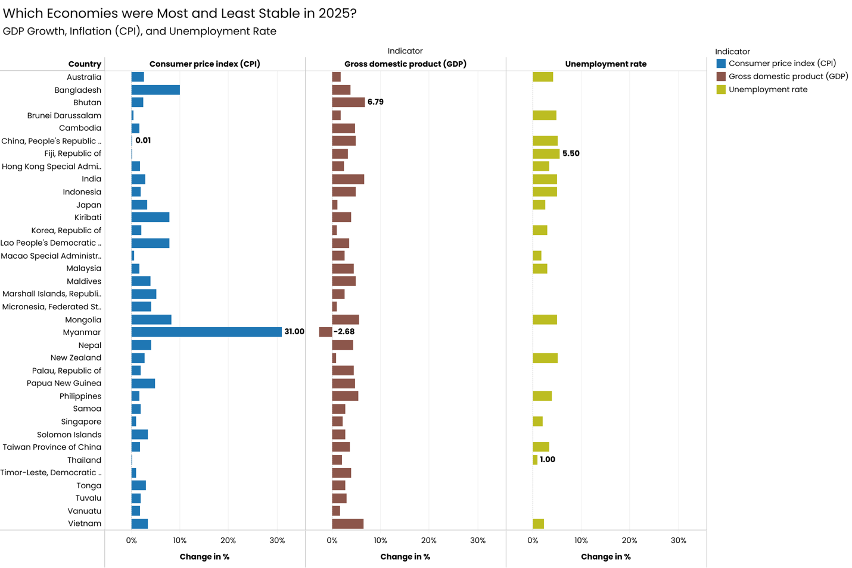
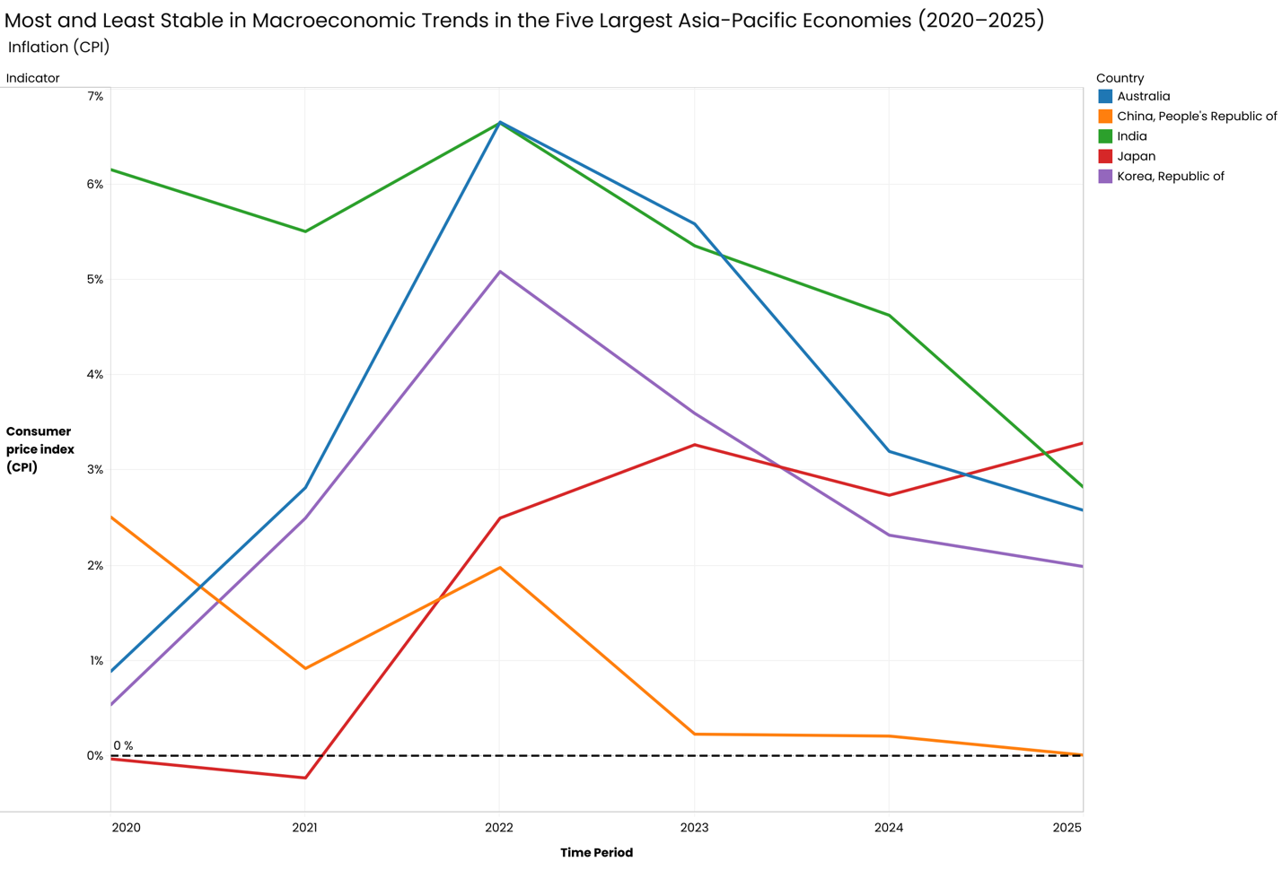
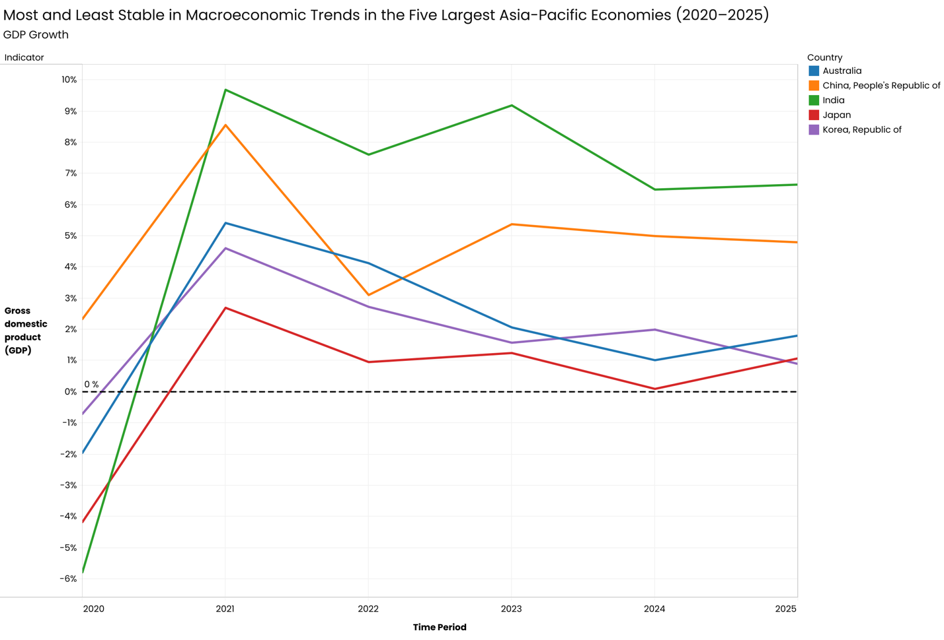
Investment and Saving Trends
The regional landscape in 2025 shows extreme variance, ranging from Macao’s substantial surplus of 35.51% to Timor-Leste’s significant deficit of -31.07%. These fluctuations, particularly the volatility seen in the Republic of Korea, underscore the complex macroeconomic trade-offs between domestic consumption and external investment.

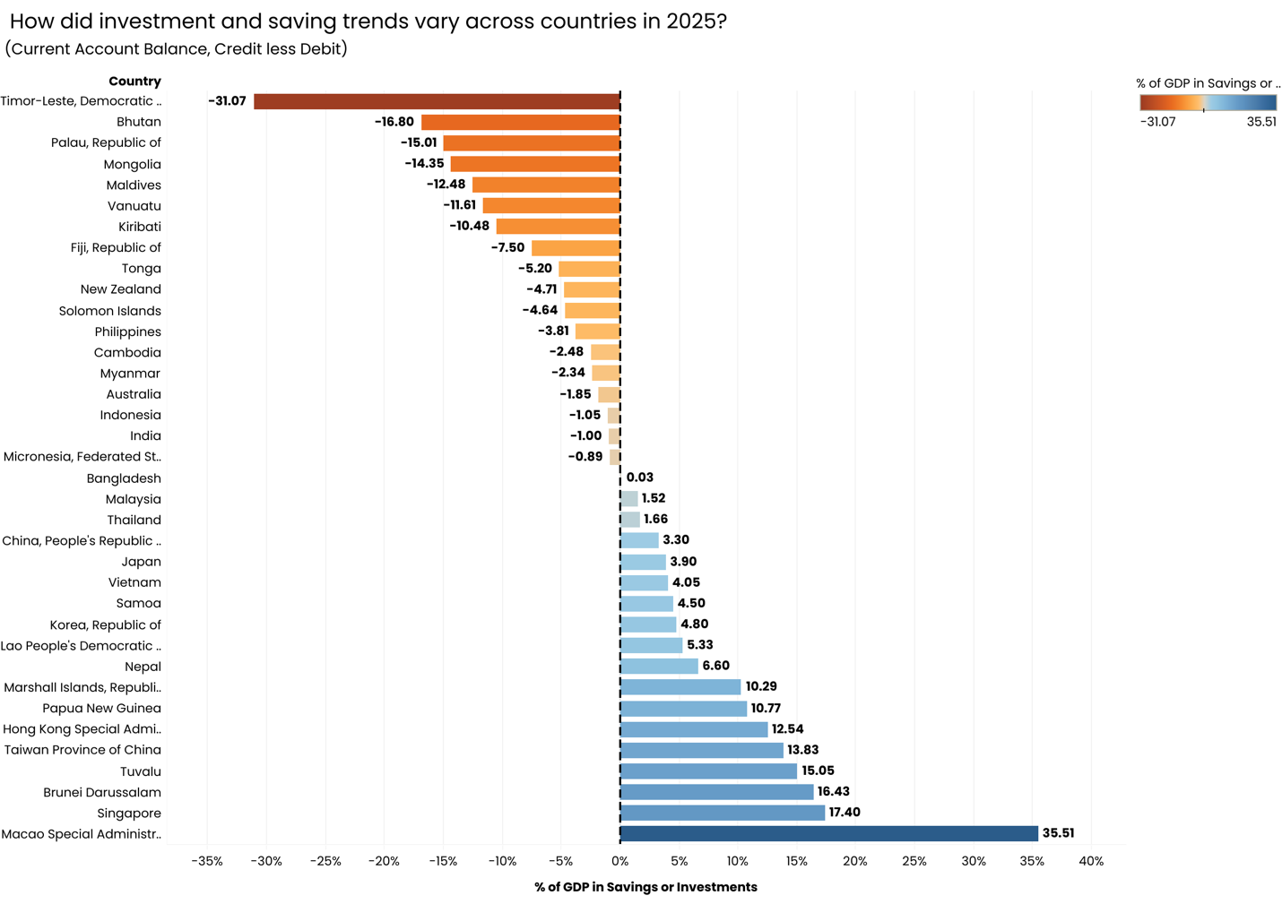

Between 2020 and 2025, major economies like Japan and China maintained consistent surpluses, with Japan projected to reach a high of 3.90% by 2025. Conversely, Australia and India have transitioned into deeper deficit spending, with Australia’s balance dipping to -1.85% of GDP by the end of the period

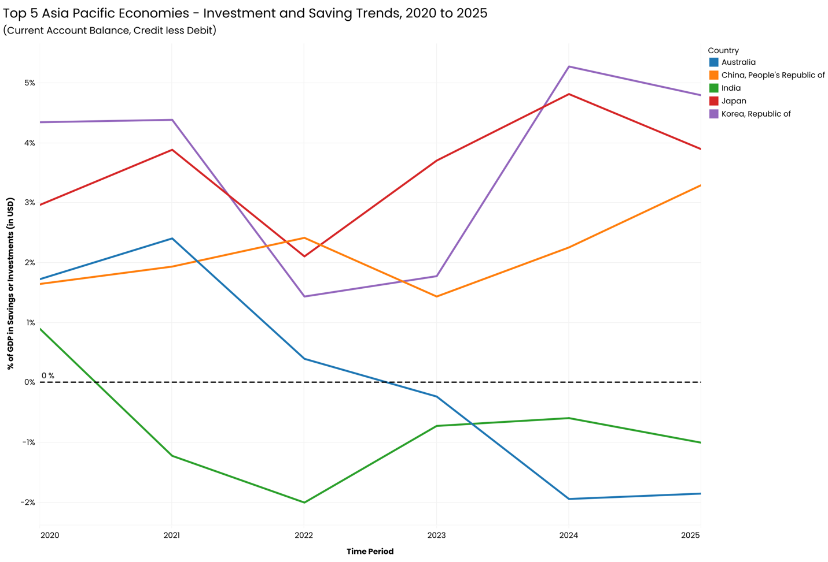

Asia-Pacific Macroeconomic Dashboard – Link to the dashboard.

Recommendations
- Monitor economies with high growth volatility as potential sources of macroeconomic risk.
- Incorporate inflation–growth divergence into monetary and investment sensitivity analysis.
- Use current account trends as early indicators of external vulnerability under tightening global conditions.
- Prioritise economies demonstrating consistent growth and labour market stability for long-term strategic planning.

Limitations and Assumptions
The analysis relies on reported macroeconomic indicators that may be revised over time. Cross-country comparability is affected by methodological differences in labour and price measurement. The use of selected economies for visual clarity may underrepresent smaller regional dynamics.

Scope of Future Work
Future analysis could integrate fiscal balance data, debt sustainability metrics, or exchange rate volatility to deepen structural risk assessment. Extending the time horizon beyond 2025 would also support long-cycle trend evaluation.

Conclusion
This report demonstrates how structured macroeconomic analysis can translate APDREO data into actionable regional insights. By combining growth, inflation, labour, and external balance indicators, the analysis highlights not only performance differences but also underlying stability and risk profiles across Asia-Pacific economies.

Appendix
Supporting SQL queries, data preparation scripts, and detailed exploratory analysis are provided in the accompanying R Markdown document.

Asia-Pacific Economic Dynamics (2020–2025)
Kaustubh Sardesai
2026-01-17

## Checking what countriea are involved in ADREO
SELECT DISTINCT COUNTRY
FROM data_original;

## Creating a staging table
CREATE TABLE data_original_staging
LIKE data_original
;

INSERT INTO data_original_staging
SELECT*
FROM data_original
;

## 1. Remove Duplicates

##If ROW_NUM is 2 its a duplicate

SELECT *,
ROW_NUMBER() OVER
(PARTITION BY COUNTRY,INDICATOR,FREQUENCY,TIME_PERIOD,OBS_VALUE,SCALE,`PRECISION`,DECIMALS_DISPLAYED,INT_ACC_ITEM,NA_STO,GFS_STO,COICOP_1999,SOC_CONCEPTS,SECTOR,INDEX_TYPE,PRICES,STATISTICAL_MEASURES,TRANSFORMATION,
UNIT,DERIVATION_TYPE,OVERLAP,DOI,FULL_DESCRIPTION,AUTHOR,PUBLISHER,DEPARTMENT,CONTACT_POINT,TOPIC,TOPIC_DATASET,KEYWORDS,KEYWORDS_DATASET,`LANGUAGE`,PUBLICATION_DATE,UPDATE_DATE,METHODOLOGY,
METHODOLOGY_NOTES,ACCESS_SHARING_LEVEL,ACCESS_SHARING_NOTES,SECURITY_CLASSIFICATION,`SOURCE`,SHORT_SOURCE_CITATION,FULL_SOURCE_CITATION,LICENSE,SUGGESTED_CITATION,KEY_INDICATOR,SERIES_NAME)
AS ROW_NUM
FROM data_original_staging
;

## Filtering for Duplicates using CTEs
WITH duplicate_cte AS
(
SELECT *,
ROW_NUMBER() OVER
(PARTITION BY COUNTRY,INDICATOR,FREQUENCY,TIME_PERIOD,OBS_VALUE,SCALE,`PRECISION`,DECIMALS_DISPLAYED,INT_ACC_ITEM,NA_STO,GFS_STO,COICOP_1999,SOC_CONCEPTS,SECTOR,INDEX_TYPE,PRICES,STATISTICAL_MEASURES,TRANSFORMATION,
UNIT,DERIVATION_TYPE,OVERLAP,DOI,FULL_DESCRIPTION,AUTHOR,PUBLISHER,DEPARTMENT,CONTACT_POINT,TOPIC,TOPIC_DATASET,KEYWORDS,KEYWORDS_DATASET,`LANGUAGE`,PUBLICATION_DATE,UPDATE_DATE,METHODOLOGY,
METHODOLOGY_NOTES,ACCESS_SHARING_LEVEL,ACCESS_SHARING_NOTES,SECURITY_CLASSIFICATION,`SOURCE`,SHORT_SOURCE_CITATION,FULL_SOURCE_CITATION,LICENSE,SUGGESTED_CITATION,KEY_INDICATOR,SERIES_NAME)
AS ROW_NUM
FROM data_original_staging
)
SELECT*
FROM duplicate_cte
WHERE ROW_NUM > 1
;
## No Duplicates found

## Creating a staging table to manupulate and remove unncessary data
CREATE TABLE `data_original_staging_2` (
`COUNTRY` varchar(100) DEFAULT NULL,
`INDICATOR` varchar(500) DEFAULT NULL,
`FREQUENCY` varchar(20) DEFAULT NULL,
`TIME_PERIOD` varchar(10) DEFAULT NULL,
`OBS_VALUE` decimal(38,15) DEFAULT NULL,
`SCALE` varchar(50) DEFAULT NULL,
`PRECISION` varchar(50) DEFAULT NULL,
`DECIMALS_DISPLAYED` varchar(50) DEFAULT NULL,
`INT_ACC_ITEM` varchar(200) DEFAULT NULL,
`NA_STO` varchar(200) DEFAULT NULL,
`GFS_STO` varchar(200) DEFAULT NULL,
`COICOP_1999` varchar(200) DEFAULT NULL,
`SOC_CONCEPTS` varchar(200) DEFAULT NULL,
`SECTOR` varchar(200) DEFAULT NULL,
`INDEX_TYPE` varchar(200) DEFAULT NULL,
`PRICES` varchar(200) DEFAULT NULL,
`STATISTICAL_MEASURES` varchar(200) DEFAULT NULL,
`TRANSFORMATION` varchar(200) DEFAULT NULL,
`UNIT` varchar(100) DEFAULT NULL,
`DERIVATION_TYPE` varchar(100) DEFAULT NULL,
`OVERLAP` varchar(100) DEFAULT NULL,
`DOI` varchar(200) DEFAULT NULL,
`FULL_DESCRIPTION` text,
`AUTHOR` varchar(200) DEFAULT NULL,
`PUBLISHER` varchar(200) DEFAULT NULL,
`DEPARTMENT` varchar(200) DEFAULT NULL,
`CONTACT_POINT` varchar(200) DEFAULT NULL,
`TOPIC` varchar(500) DEFAULT NULL,
`TOPIC_DATASET` varchar(500) DEFAULT NULL,
`KEYWORDS` varchar(500) DEFAULT NULL,
`KEYWORDS_DATASET` varchar(500) DEFAULT NULL,
`LANGUAGE` varchar(50) DEFAULT NULL,
`PUBLICATION_DATE` varchar(50) DEFAULT NULL,
`UPDATE_DATE` varchar(50) DEFAULT NULL,
`METHODOLOGY` varchar(200) DEFAULT NULL,
`METHODOLOGY_NOTES` text,
`ACCESS_SHARING_LEVEL` varchar(100) DEFAULT NULL,
`ACCESS_SHARING_NOTES` text,
`SECURITY_CLASSIFICATION` varchar(100) DEFAULT NULL,
`SOURCE` varchar(500) DEFAULT NULL,
`SHORT_SOURCE_CITATION` varchar(500) DEFAULT NULL,
`FULL_SOURCE_CITATION` text,
`LICENSE` varchar(500) DEFAULT NULL,
`SUGGESTED_CITATION` text,
`KEY_INDICATOR` varchar(10) DEFAULT NULL,
`SERIES_NAME` varchar(500) DEFAULT NULL
) ENGINE=InnoDB DEFAULT CHARSET=utf8mb4 COLLATE=utf8mb4_0900_ai_ci
;

## Adding all the data from data_original to data_orginal_staging
INSERT INTO data_original_staging_2
SELECT*
FROM data_original_staging
;

## Deleting unwanted coloumns
ALTER TABLE data_original_staging_2
DROP COLUMN DECIMALS_DISPLAYED,
DROP COLUMN INT_ACC_ITEM,
DROP COLUMN GFS_STO,
DROP COLUMN COICOP_1999,
DROP COLUMN SOC_CONCEPTS,
DROP COLUMN SECTOR,
DROP COLUMN INDEX_TYPE,
DROP COLUMN PRICES,
DROP COLUMN STATISTICAL_MEASURES,
DROP COLUMN TRANSFORMATION,
DROP COLUMN UNIT,
DROP COLUMN DERIVATION_TYPE,
DROP COLUMN OVERLAP,
DROP COLUMN DOI,
DROP COLUMN FULL_DESCRIPTION,
DROP COLUMN AUTHOR,
DROP COLUMN PUBLISHER,
DROP COLUMN DEPARTMENT,
DROP COLUMN CONTACT_POINT,
DROP COLUMN TOPIC,
DROP COLUMN TOPIC_DATASET,
DROP COLUMN KEYWORDS,
DROP COLUMN KEYWORDS_DATASET,
DROP COLUMN `LANGUAGE`,
DROP COLUMN PUBLICATION_DATE,
DROP COLUMN UPDATE_DATE,
DROP COLUMN METHODOLOGY,
DROP COLUMN METHODOLOGY_NOTES,
DROP COLUMN ACCESS_SHARING_LEVEL,
DROP COLUMN ACCESS_SHARING_NOTES,
DROP COLUMN SECURITY_CLASSIFICATION,
DROP COLUMN `SOURCE`,
DROP COLUMN SHORT_SOURCE_CITATION,
DROP COLUMN FULL_SOURCE_CITATION,
DROP COLUMN LICENSE,
DROP COLUMN SUGGESTED_CITATION,
DROP COLUMN KEY_INDICATOR,
DROP COLUMN SERIES_NAME,
DROP COLUMN NA_STO,
DROP COLUMN `PRECISION`;
;

## Removing unwanted Rows
DELETE FROM data_original_staging_2
WHERE TIME_PERIOD < 2020
;

DELETE FROM data_original_staging_2
WHERE TIME_PERIOD >= 2026
;

## Checking what indicators involved in ADREO data
SELECT DISTINCT INDICATOR
FROM data_original_staging_2
;

DELETE FROM data_original_staging_2
WHERE INDICATOR = 'Gross domestic product (GDP), Constant prices, Purchasing power parity (PPP) per capita percent change'
;

DELETE FROM data_original_staging_2
WHERE INDICATOR = 'All Items, Consumer price index (CPI), End-of-period (EoP), percent change'
;

ALTER TABLE data_original_staging_2
MODIFY OBS_VALUE DECIMAL(10,2)
;

## Answering questions in the brief
## Which Asia-Pacific economies show the strongest and weakest GDP growth trends?

## 2025
SELECT *
FROM data_original_staging_2
WHERE INDICATOR = 'Gross domestic product (GDP), Constant prices, Per cent change, Domestic currency'
AND TIME_PERIOD = 2025
;

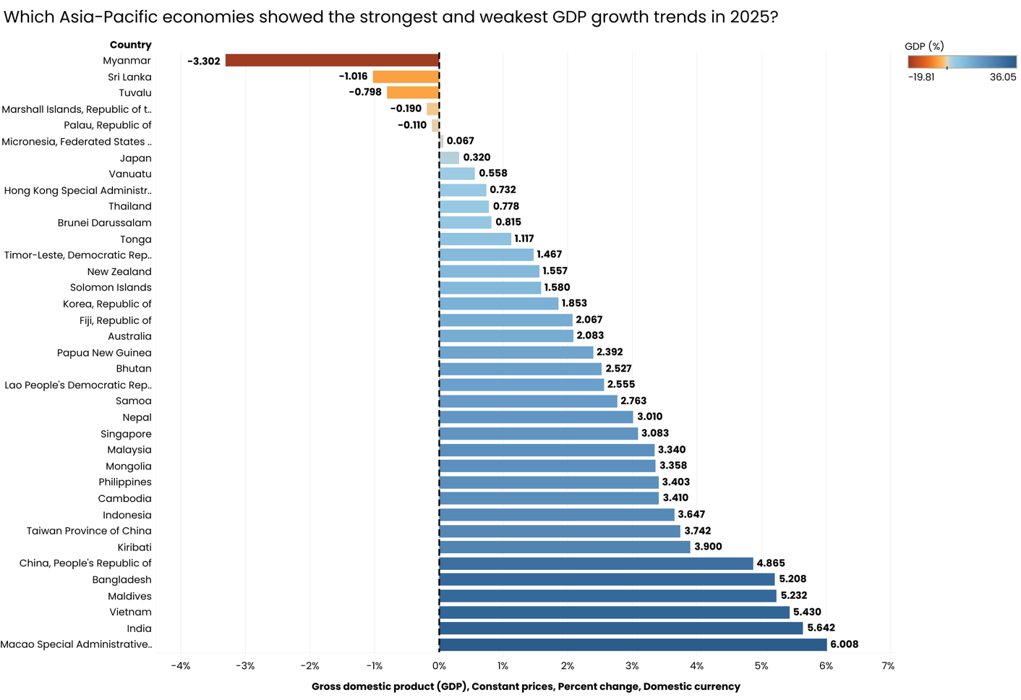

## 2020-2025 (Only largest 5 economies will be used for data viz - China, Japan, India, Australia, Korea)
SELECT *
FROM data_original_staging_2
WHERE INDICATOR = 'Gross domestic product (GDP), Constant prices, Percent change, Domestic currency'
AND TIME_PERIOD BETWEEN 2020 And 2025
;
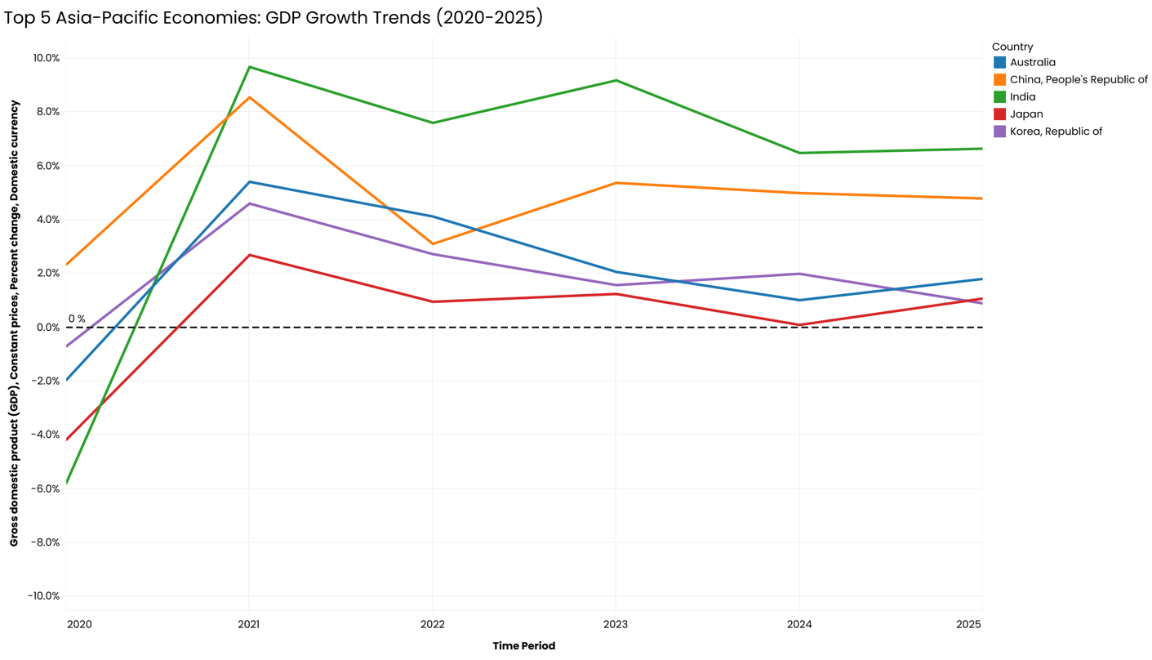

## How do investment and saving trends vary across countries?

##2025
SELECT *
FROM data_original_staging_2
WHERE INDICATOR = 'Current account balance (credit less debit), Percent of GDP in US dollars'
AND TIME_PERIOD = 2025
;
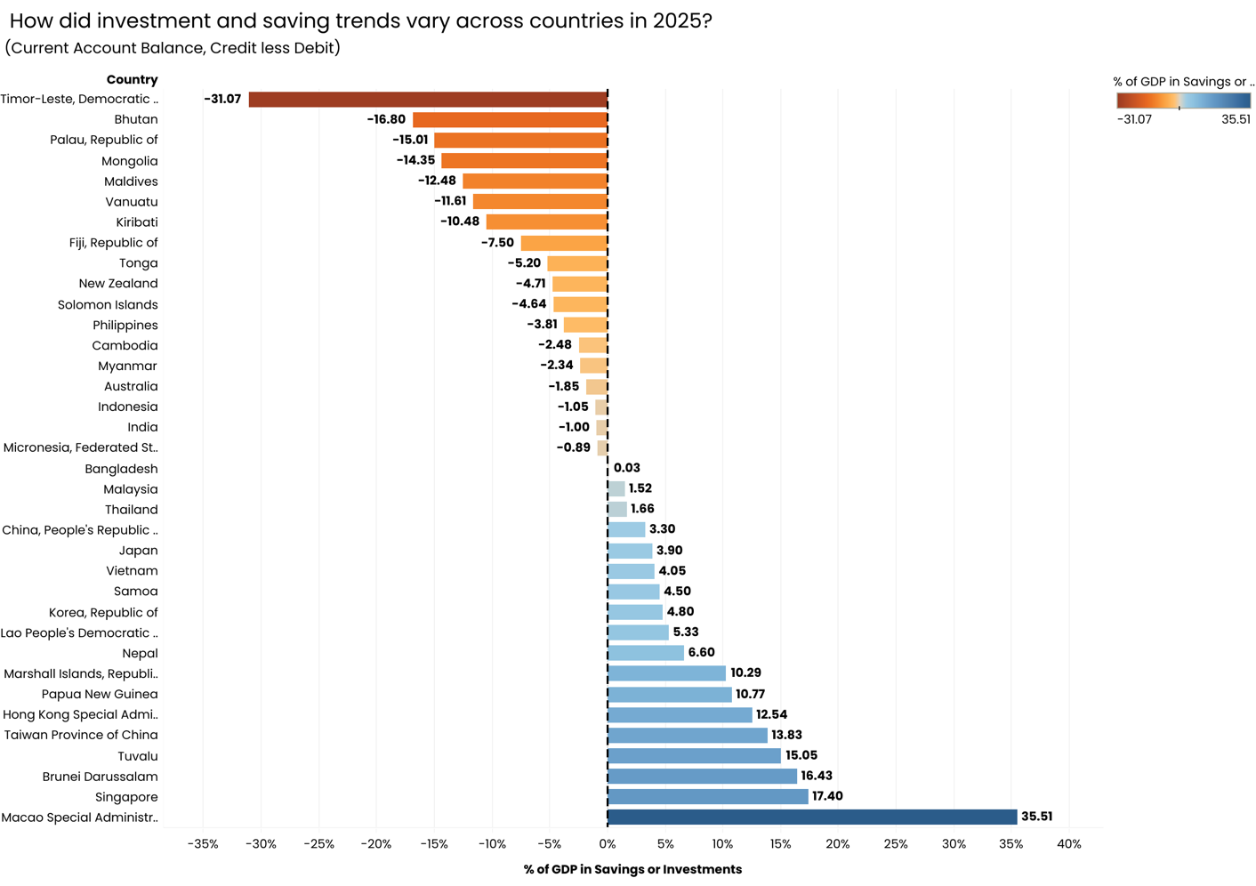

## 2020-2025 (Only largest 5 economies will be used for data viz - China, Japan, India, Australia, Korea)
SELECT *
FROM data_original_staging_2
WHERE INDICATOR = 'Current account balance (credit less debit), Percent of GDP in US dollars'
;
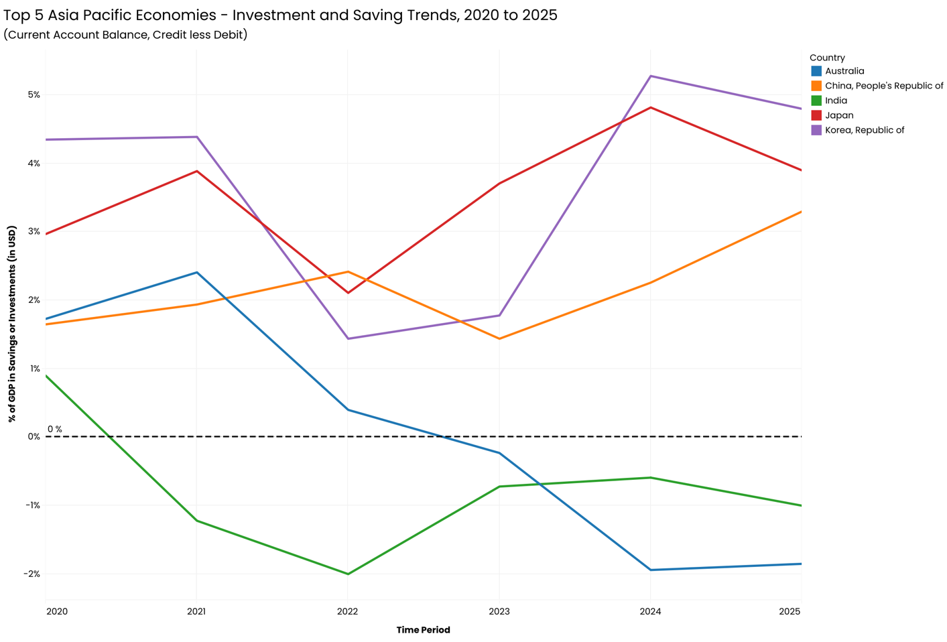

## Which economies appear most stable vs volatile over time?

##2025
SELECT *
FROM data_original_staging_2
WHERE INDICATOR IN (
'Unemployment rate',
'All Items, Consumer price index (CPI), Period average, percent change',
'Gross domestic product (GDP), Constant prices, Percent change, Domestic currency'
)
AND TIME_PERIOD = 2025;

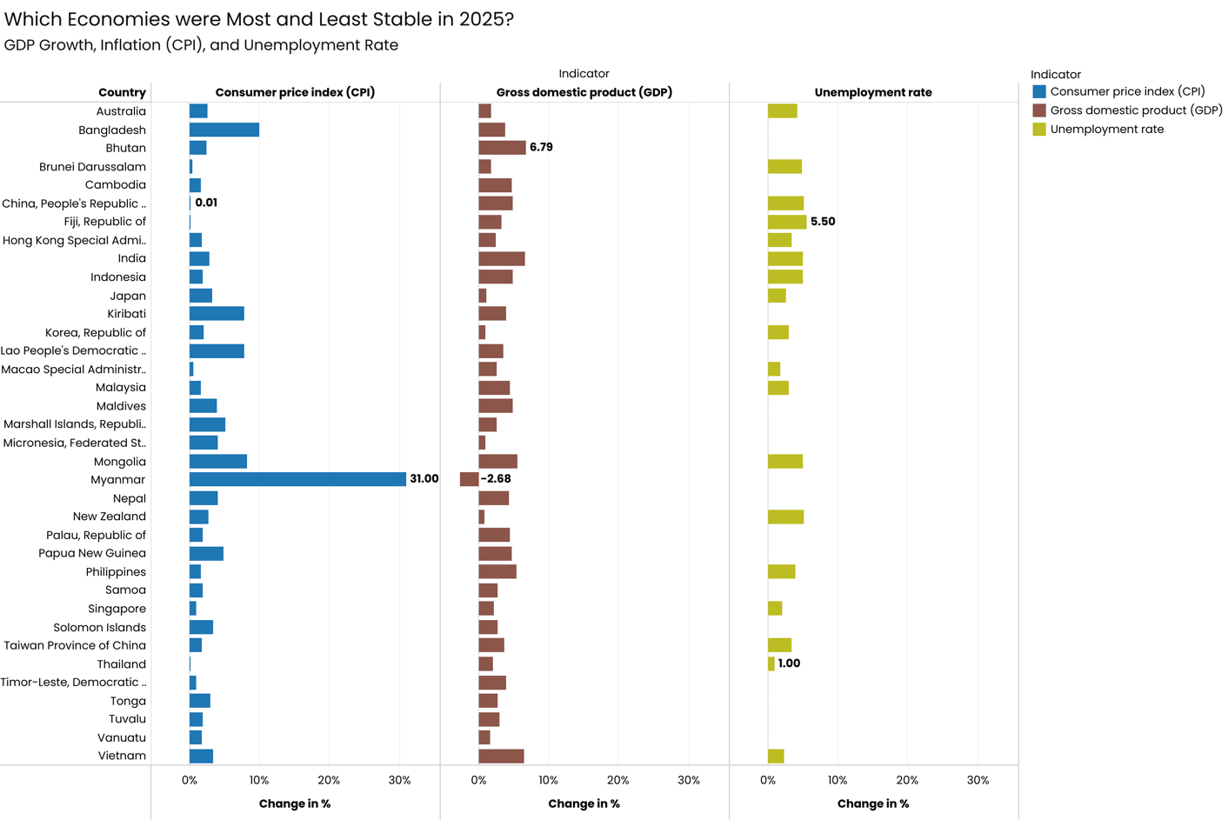

## 2020-2025 (Only largest 5 economies will be used for data viz - China, Japan, India, Australia, Korea) 3 different data vizz as there are 3 indicators over 5 years
SELECT *
FROM data_original_staging_2
WHERE INDICATOR IN (
'Unemployment rate',
'All Items, Consumer price index (CPI), Period average, percent change',
'Gross domestic product (GDP), Constant prices, Percent change, Domestic currency'
)
;
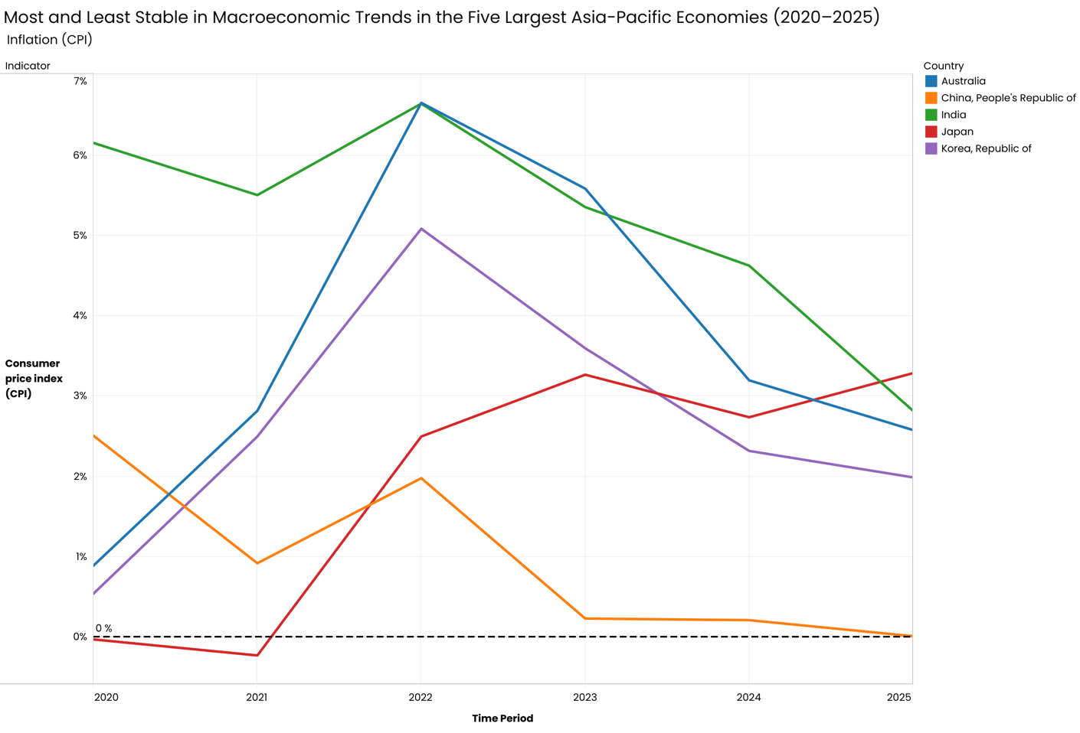

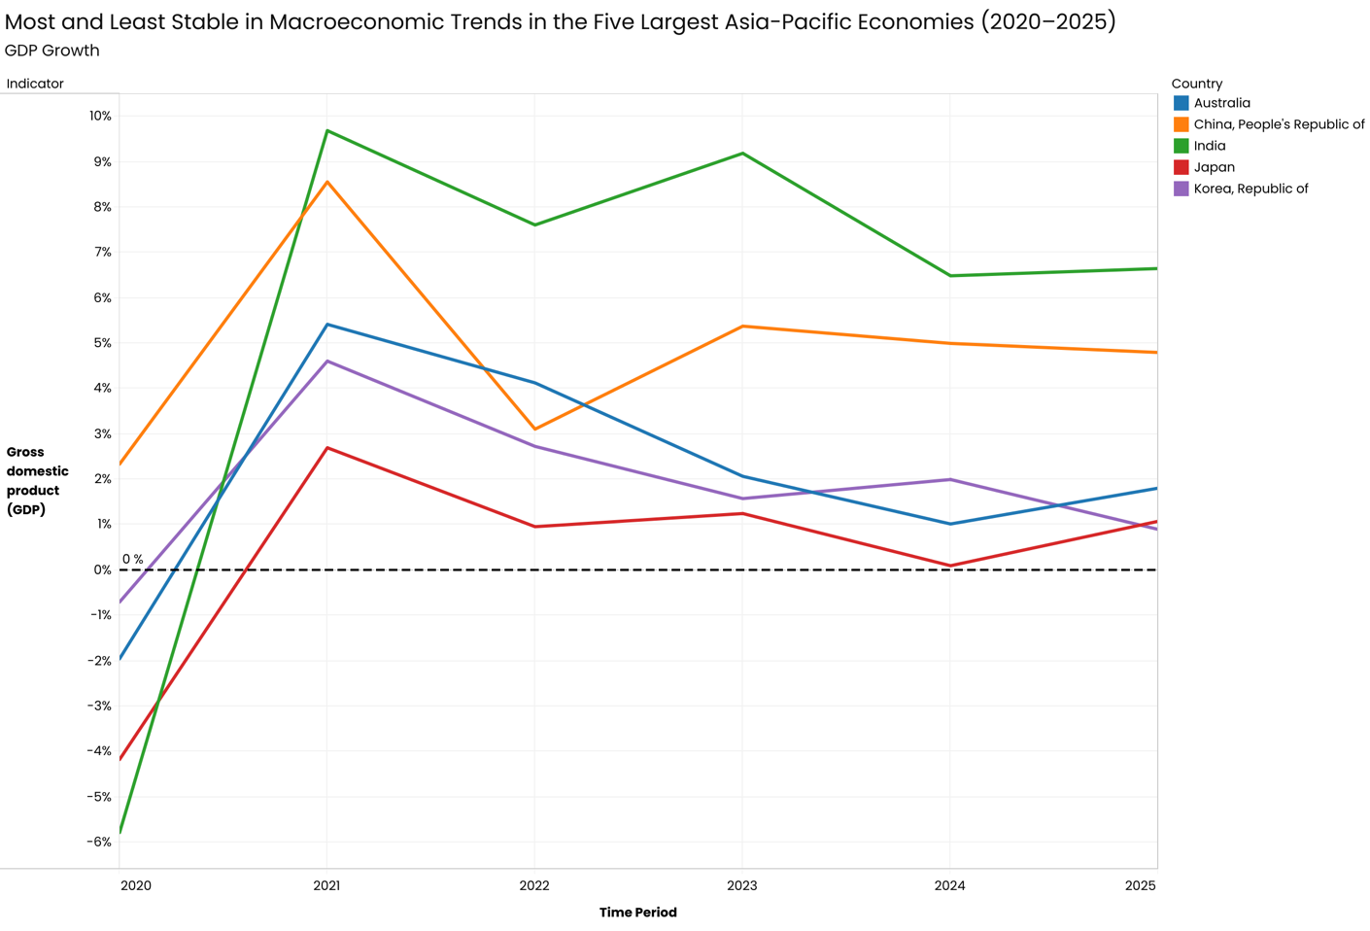

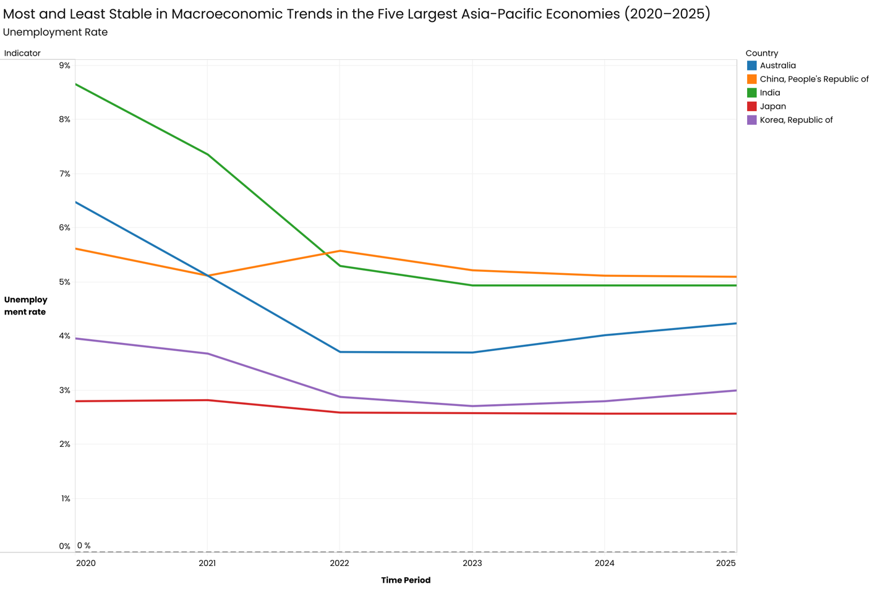

## Are high growth economies also experiencing higher inflation?
## Compare average GDP growth vs average inflation by country (or year-by-year correlation).

## 2025
SELECT COUNTRY,
AVG(CASE
WHEN INDICATOR = 'Gross domestic product (GDP), Constant prices, Percent change, Domestic currency'
THEN OBS_VALUE
END) AS avg_gdp_growth,
AVG(CASE
WHEN INDICATOR = 'All Items, Consumer price index (CPI), Period average, percent change'
THEN OBS_VALUE
END) AS avg_inflation
FROM data_original_staging_2
WHERE TIME_PERIOD = 2025
GROUP BY COUNTRY
;

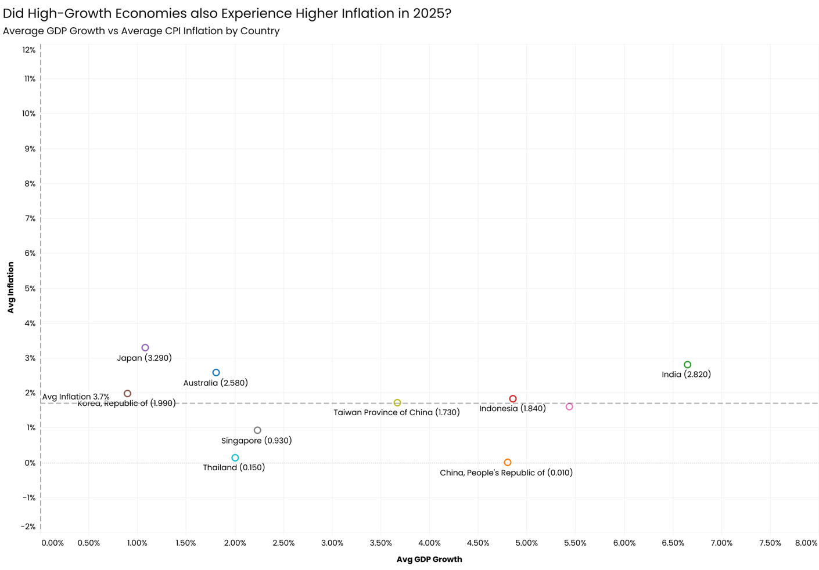

## 2020-2025 (Only largest 5 economies will be used for data viz - China, Japan, India, Australia, Korea)
SELECT COUNTRY,
AVG(CASE
WHEN INDICATOR = 'Gross domestic product (GDP), Constant prices, Percent change, Domestic currency'
THEN OBS_VALUE
END) AS avg_gdp_growth,
AVG(CASE
WHEN INDICATOR = 'All Items, Consumer price index (CPI), Period average, percent change'
THEN OBS_VALUE
END) AS avg_inflation
FROM data_original_staging_2
WHERE TIME_PERIOD BETWEEN 2020 AND 2025
GROUP BY COUNTRY
;

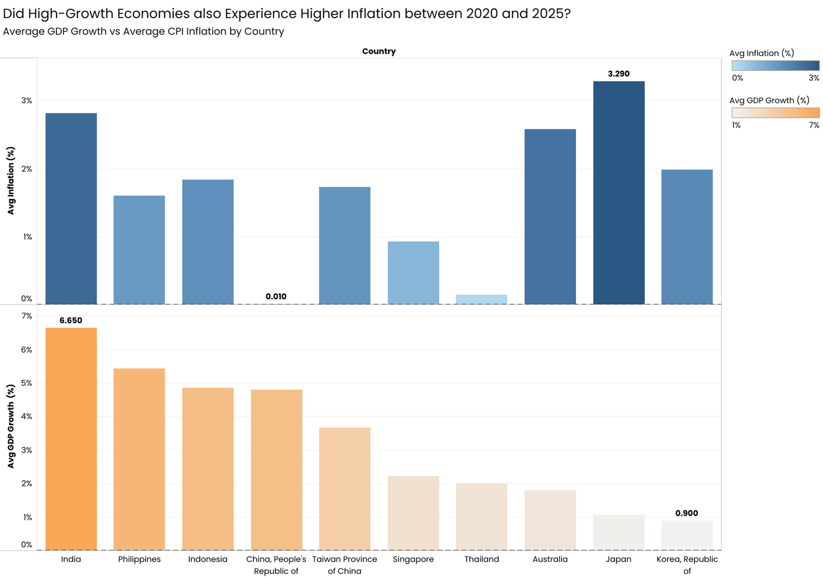

## Which economies show consistent growth?
## “Consistency” = low volatility + positive average growth

SELECT COUNTRY,
AVG(OBS_VALUE) AS avg_gdp_growth,
MAX(OBS_VALUE) - MIN(OBS_VALUE) AS gdp_growth_range
FROM data_original_staging_2
WHERE INDICATOR = 'Gross domestic product (GDP), Constant prices, Percent change, Domestic currency'
AND TIME_PERIOD BETWEEN 2020 AND 2025
GROUP BY COUNTRY
;

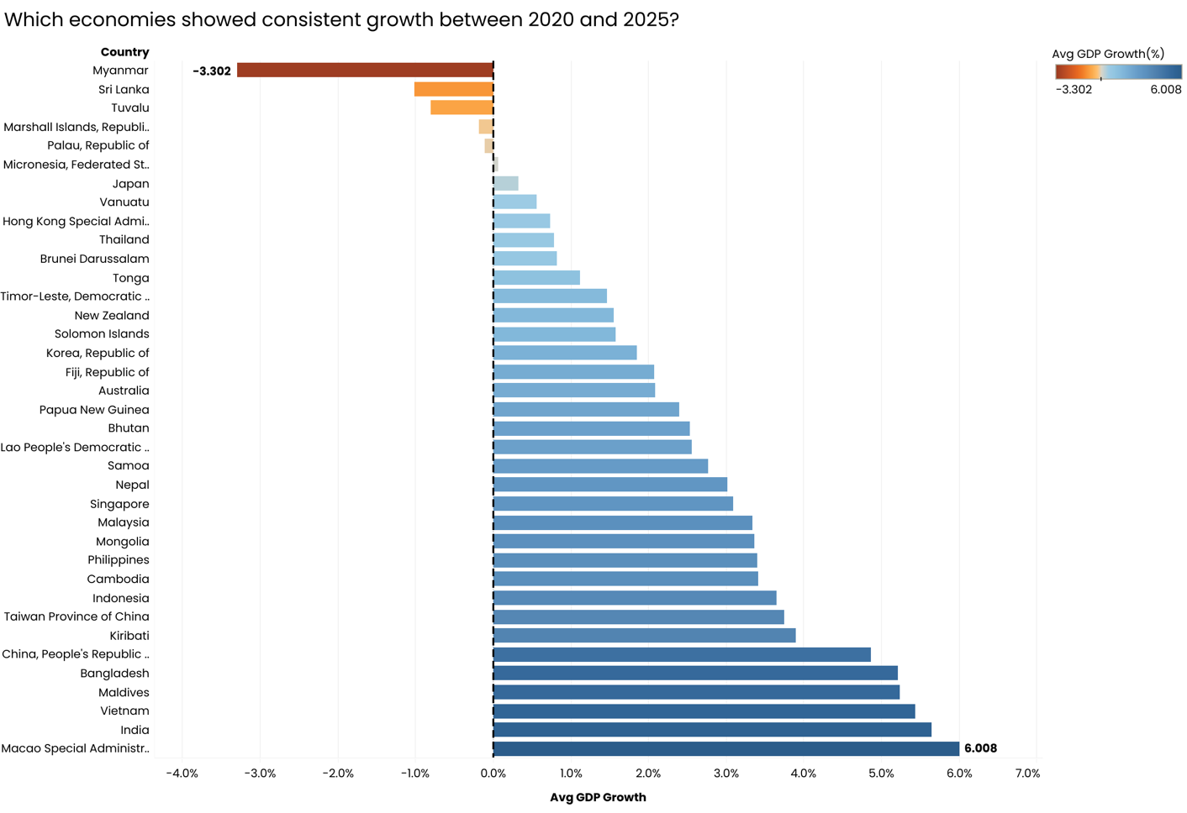

## Which economies are structurally dependent on foreign capital?
## Persistent negative current account balance = reliance on foreign capital

##2025
SELECT COUNTRY,
AVG(OBS_VALUE) AS avg_current_account_balance
FROM data_original_staging_2
WHERE INDICATOR = 'Current account balance (credit less debit), Percent of GDP in US dollars'
AND TIME_PERIOD = 2025
GROUP BY COUNTRY
;

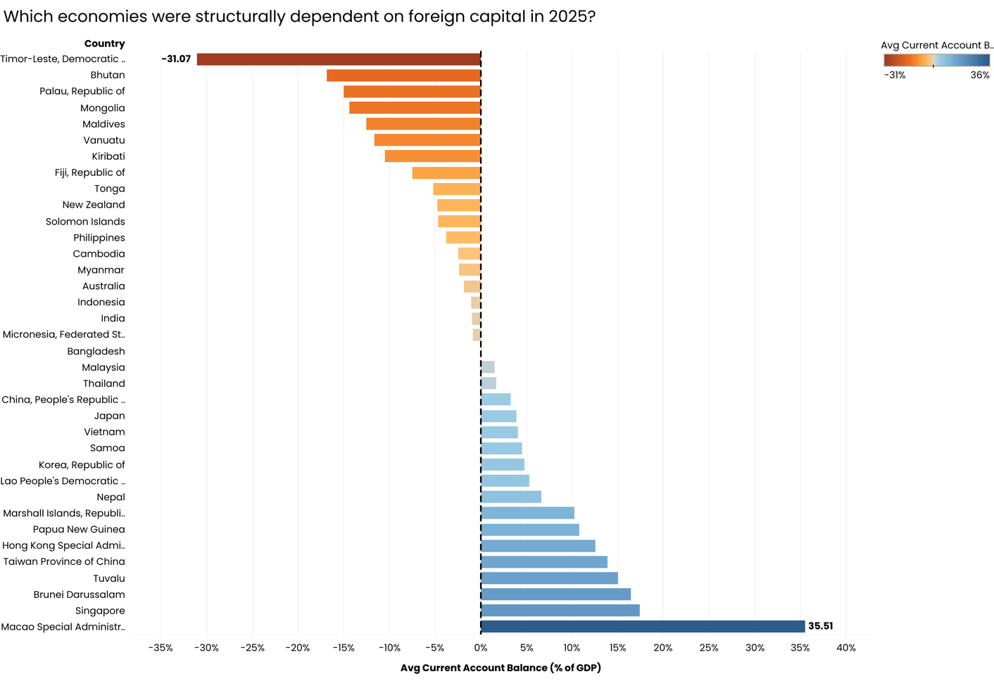

## Who performs best on a low inflation + low unemployment metric?
## Lowest average inflation, Lowest average unemployment

## 2020-2025
SELECT COUNTRY,
AVG(CASE
WHEN INDICATOR = 'All Items, Consumer price index (CPI), Period average, percent change'
THEN OBS_VALUE
END) AS avg_inflation,
COALESCE(AVG(CASE
WHEN INDICATOR = 'Unemployment rate'
THEN OBS_VALUE END), 0) AS avg_unemployment -- Replaces NULL avg result with 0
FROM data_original_staging_2
WHERE TIME_PERIOD BETWEEN 2020 AND 2025
GROUP BY COUNTRY
ORDER BY avg_inflation ASC, avg_unemployment ASC
;
